

Software Engineering
Year 11 Project
OO Analysis and Design Report

Table of Contents

Introduction 2
Business Requirements 2
Requirements Report 3
Functional Requirements 3
Use Cases 3
Use Case Descriptions: 3
Use Case 1: Introduction 3
Use Case 2: Customer Greeting 3
Non Functional Requirements 6
Design Report 7
UML Component Diagram 7
UML Class Diagram 8
Database Schema 9

,

Introduction

In this report, I have highlighted the requirements necessary for the development of the Food Ordering Chatbot that will help the users in identifying themselves, viewing menu, placing orders and viewing past orders using an interactive and conversational user interface that is assisted through voice communication.

The document comprises of the Requirements Report that consists of the list of the Client Needs (the Business Requirements), Functional Requirements which satisfy the client needs (as Use Case & Data Flow Diagram) and Non-Functional Requirements that highlight the technical specifications of the system.

Following the Requirements Report is the Design Report. The Design Report consists of the UML Component Diagram, UML Class Diagram and Database Schema Diagram.

Business Requirements

The client needs explain the main reasons of “why” the project is taking place. This represents the “brief” for the project and summarises the conversation between the Systems Analyst and the Client to identify the motivation for the project.

In this project, we will be developing a system that provides a way for a Customer to communicate with the Food Ordering Service in a seamless manner. The Restaurant, "Babcia's Kitchen", needs to develop an ordering service which would be user-friendly and should not involve manual intervention for all orders and maintain records of customers and orders.

The system needs to:
- identify whether a customer is a new or existing customer and then greet him/her using his/her name.
- Register a new customer and store his/her details for later use.
- Display food menus and food items available on each menu along with prices.
- Order food by choosing food items and quantity to order; the order must have at least three food items.
- Check out order (order basket) before confirming the order and cancel the order if necessary.
- Store each confirmed order against the respective customer account; dishes ordered, their quantity and prices at which they were ordered, and total price must be stored with each order.
- Display order history of the customer.
- Thank the customer using his/her name when he/she leaves.
- Enable natural conversation flow with support for common language usage.
- Use voice-based interaction system; the system should answer the questions and listen to answers provided by the customer.
- Persistently store all data.

Requirements Report

Functional Requirements

Use Cases
The following is a Use Case Diagram documenting the main functions that the system must provide in order to satisfy the client needs.

UML Use Case Diagram that shows the interactions between the external user and the system functions.
- https://www.lucidchart.com/pages/uml-use-case-diagramLinks to an external site.
- https://en.wikipedia.org/wiki/Use_case_diagram

A use case diagram is a graphical depiction of a user's possible interactions with a system. A use case diagram shows various use cases and different types of users the system has and will often be accompanied by other types of diagrams as well. The use cases are represented by either circles or ellipses. The actors are often shown as stick figures.
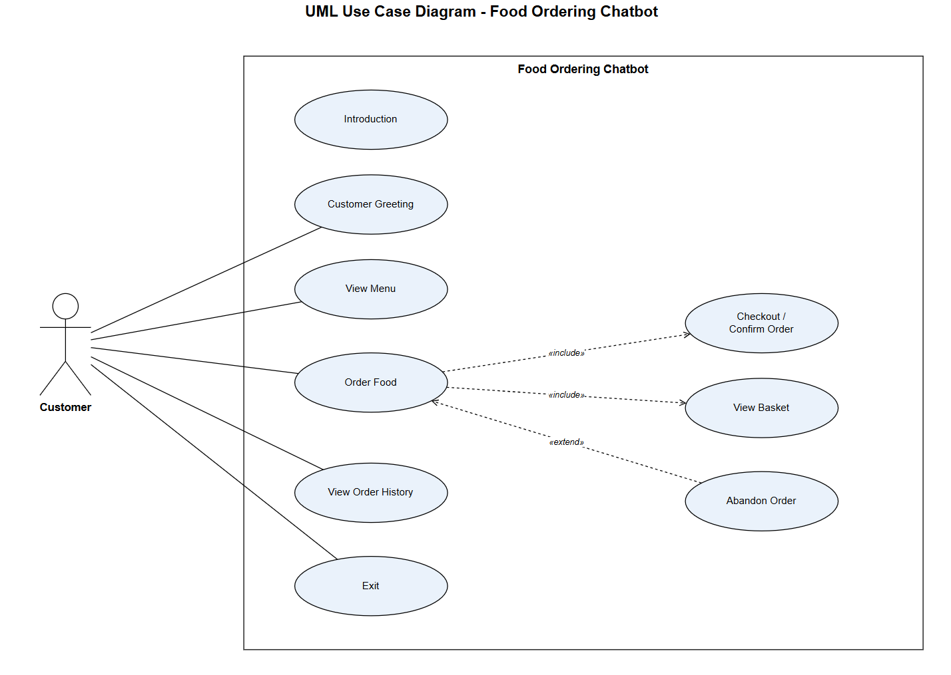

Use Case Descriptions:
The following use cases describes the functional requirements of the system.

Use Case 1: Introduction
- Waiter introduces themselves and welcomes customer to the System in a polite way

Use Case 2: Customer Greeting
- Waiter welcomes custom0065r in a polite way
- If the customer already exists, Waiter asks for their password and, once correct, welcomes the returning customer back by name.
- If the customer is already registered, Waiter asks for their password and, once it's right, greets the returning customer by their name.
- If the customer is not registered yet, Waiter registers the customer by asking for the password and first and last names, creates the customer record, and greets the customer.
Use Case 3: View Menu
- Waiter presents to the customer the list of available menus (Breakfast, Lunch, Dinner).
- Waiter presents the courses and dishes available in each course, together with their prices, from one menu or all menus.
Use Case 4: Order Food
- Waiter enables the customer to add dishes to their order by choosing the menu, then the course, then the dish.
- Waiter asks the customer how many portions of the selected dish they would like.
- The customer should order at least 3 different dishes before the order can be made.
- During the process of ordering, the customer may view the menu, view the basket, complete the order, or abandon the order.
Use Case 5: View Basket
- Waiter shows the customer the dishes in their order, the quantity of each dish, and the current cost.
Use Case 6: Checkout / Confirm Order
- Waiter presents the customer with the details of the order they have made, that includes dishes, quantity and price of each dish, and total cost.
- Waiter asks the customer to confirm the order before it will be stored.
- After confirmation, Waiter stores the order in the customer's account with order number and brings the customer to the main menu.
Use Case 7: Abandon Order
- Waiter asks the customer to confirm that they want to abandon the order they have made.
- In case of confirmation, Waiter discards the order without storing it.
Use Case 8: View Order History
- Waiter presents to the customer their previous orders.
- For each order, Waiter presents the order number, the date of ordering, the dishes that were ordered and their prices at the moment of ordering, and the total value of the order.
Use Case 9: Exit
- Waiter greets the customer by name and wishes them luck, inviting to visit again.
Data Flow Diagrams

Level 1 Data Flow Diagram that shows the flows of data between the external user and the system functions

  - https://www.lucidchart.com/pages/data-flow-diagramLinks to an external site.
  - https://www.geeksforgeeks.org/dfd-for-food-ordering-system/

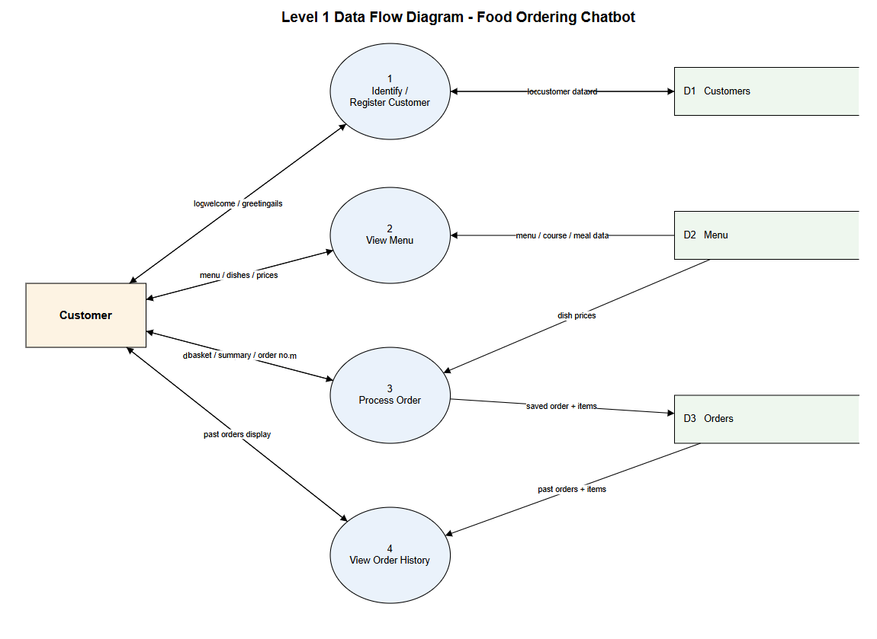

Non Functional Requirements
The following is a list of requirements for the system that do not relate to the business functions of the system, but reflect expectations from a technical perspective.

The system will require the following non-functional features:

1. Programming Techniques

a. Object Orientation

i. The system is programmed in Python with the use of Object-Oriented programming techniques – classes, objects, encapsulation (private fields are accessed via property getters) and inheritance.
ii. Each object corresponds to a real-world concept represented as a separate class (e.g. Customer, Order, OrderItem, Menu, Course, Meal) to keep data and behavior that works with it together.
iii. Inheritance is used to share common functionality – e.g. MainOptions and OrderOptions classes inherit from a base class Options rather than repeating the code.
b. Façade Design Pattern

i. The system is structured in two subsystems – Menu Subsystem and Customer & Orders Subsystem. Each subsystem is implemented as a façade class (MenuFacade and CustomerFacade respectively).
ii. The main chatbot class communicates with these two façade classes only and does not communicate with controllers, services, repositories and database underlying them.
2. Natural Conversation Flow – using fuzzy logic on inputs

a. The system understands plain language rather than requires codes or numbers. A customer can type or say a plain word (e.g. "order food", "menu", "checkout") and the system will understand it.
b. Fuzzy logic (implemented via rapidfuzz library) is applied to each input to match misspellings and variations – for example, "piza" will match to "pizza", and "ordr" will match to "order".
c. Synonyms are supported so that different words will trigger the same action – for example, a customer can "finish", "checkout", "complete" or say "done" to complete an order.
d. Confidence threshold is used so that the system will respond only if it is quite sure of a match, otherwise asking a customer to try again.
3. Voice Interaction (Accessibility)

a. To increase usability and accessibility of the system, a voice interface is available optionally at startup.
b. Text-to-Speech (pyttsx3 library) allows the chatbot to answer its questions aloud to the customer.
c. Speech Recognition (Speech Recognition library and a microphone) allows the customer to reply to questions by saying rather than typing.
d. If a speech is not recognized, the system will fall back to typed input for that particular question without breaking the conversation flow.
e. Sensitive information such as the username, password and names is always typed, because speech recognition cannot be reliably spelled.

4. Persistent Data Storage

a. All data needs to be persistent between sessions, hence the program uses a relational database (SQLite) for storing its data.
b. Customer, menus, courses, meals and orders are stored in the database, which means that a returning customer will be recognized and all his/her past orders will be available in the future.
c. Whenever an order is made, the cost of each meal is recorded as per the prices during placing the order, which ensures that all orders are accurate even when the prices on the menu change.
5. Maintainability and Reusability

a. The layered architecture (Façade → Controller → Service → Repository → Model, plus views for output) helps to separate concerns, which makes the code easier to maintain and extend.
b. Menu options and prompts are data driven – they are defined in dictionaries (MainOptions, OrderOptions) – hence it is easy to add more options just by changing the data, not modifying the program code.
c. Meaningful names of classes, methods and variables are used everywhere, which makes the code self-explanatory.

Design Report

The following is a list of Design Features that will be used to implement the Business Requirements stated above.

UML Component Diagram
(use a drawing tool such as draw.io / app.diagrams.net to draw this diagram).

A component diagram breaks down the actual system under development into various high levels of functionality. Each component is responsible for one clear aim within the entire system and only interacts with other essential elements on a need-to-know basis.

- You must produce a UML Component Diagram that reflects the Menu Component and the Customer & Orders Component
  - https://www.lucidchart.com/pages/uml-component-diagramLinks to an external site.
  - What is Component Diagram? (visual-paradigm.com)

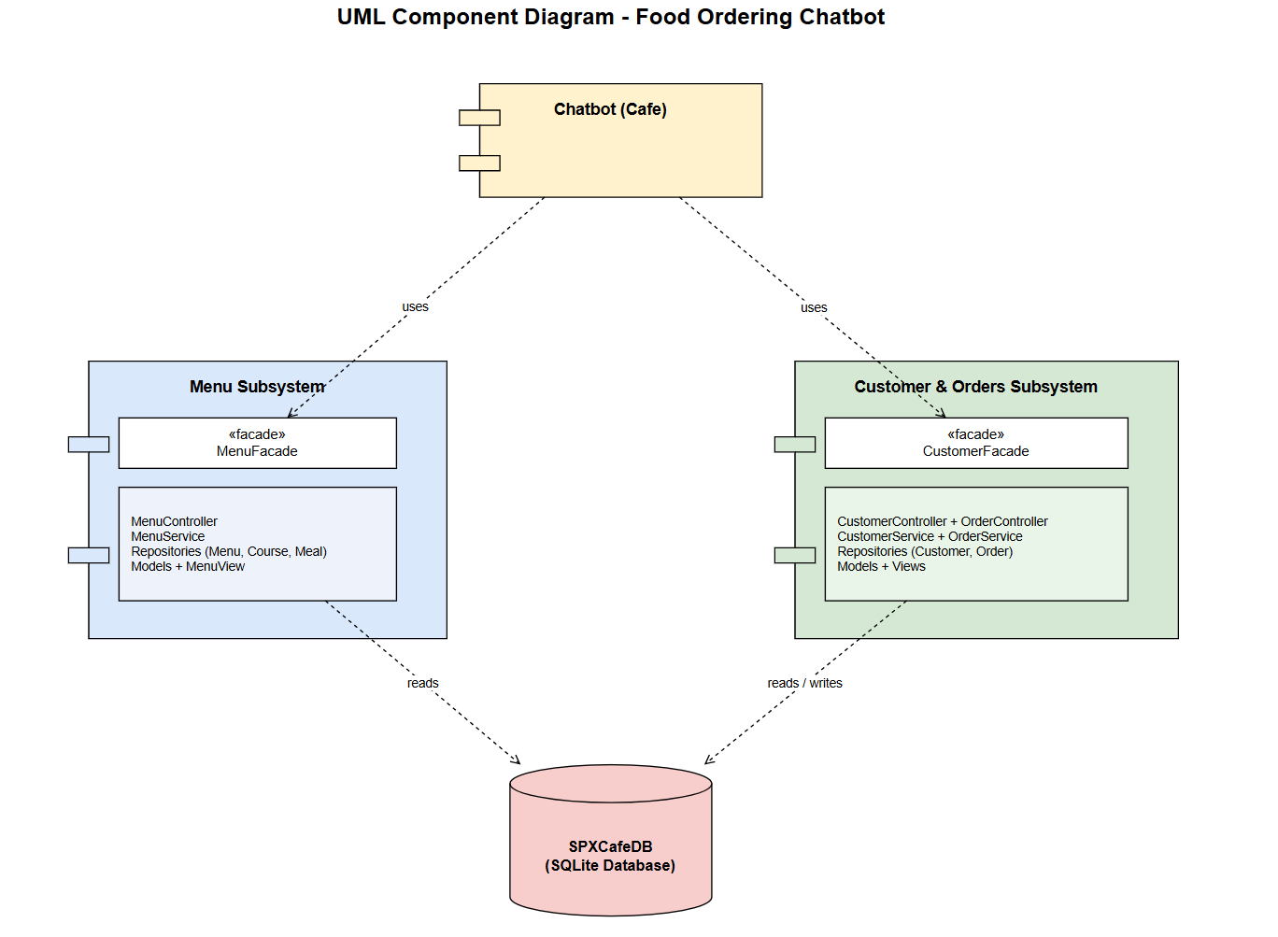

UML Class Diagram
(use a drawing tool such as draw.io / app.diagrams.net to draw this diagram)

In software engineering, a class diagram in the Unified Modeling Language (UML) is a type of static structure diagram that describes the structure of a system by showing the system's classes, their attributes, operations (or methods), and the relationships among objects.

- You must product a UML Class Diagram that reflects the Classes identified for each component and any relevant Associations between these classes
  - https://www.lucidchart.com/blog/introduction-to-class-diagrams#:~:text=So%20a%20class%20diagram%20is,aspects%20of%20complex%20software%20systemsLinks to an external site..
  - https://developer.ibm.com/articles/the-class-diagram/Links to an external site.

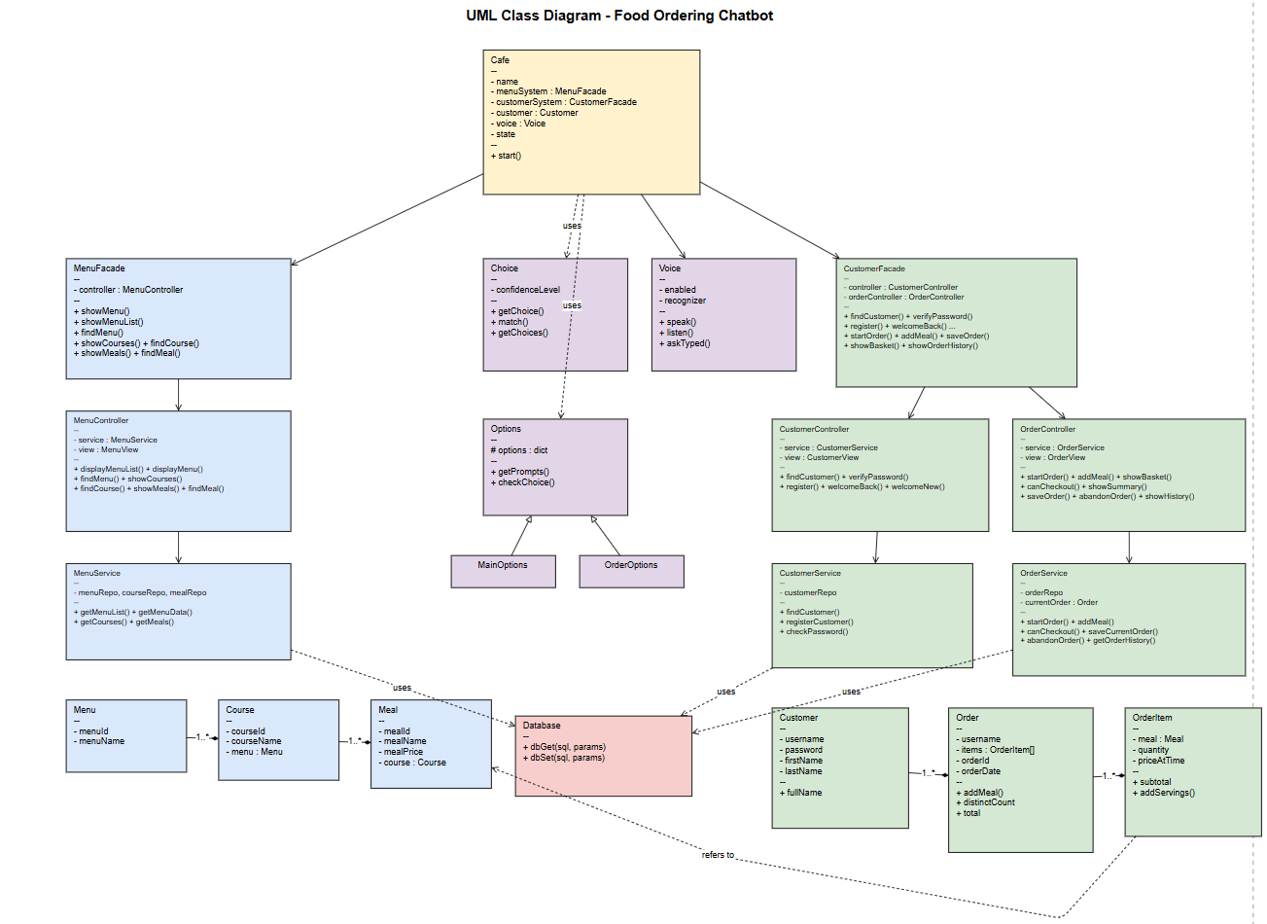

Database Schema
Include a Database Schema for the database supporting the Food Ordering System
(use a drawing tool such as draw.io / app.diagrams.net to draw this diagram)

- You must include a Database Schema diagram to reflect the database structures to support this application

